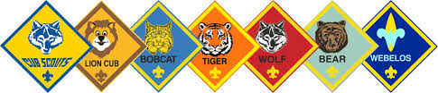
Pack 183 Meeting Agenda
Setup:
(See Assignment Sheet)

Opening Flags / Scout Oath / Scout Law:
(See Assignment Sheet)

Opening Prayer:
(See Assignment Sheet)

Program:
Skits, songs, activities

Awards:
Lions:
Tigers:
Wolves:
Bears:
Webelos:
AOL:

Announcements: (Print out the next month’s calendar)
Announcements, Announcements, Announcements,
Words of wisdom, words of wisdom,
We don’t need, We don’t need
Silly words of wisdom, Silly words of wisdom,
Nah, Nah, Nah, Nah, Nah, Nah

Cubmaster Minute:

Closing Flags:
(See Assignment Sheet)
Cleanup:
(See Assignment Sheet)
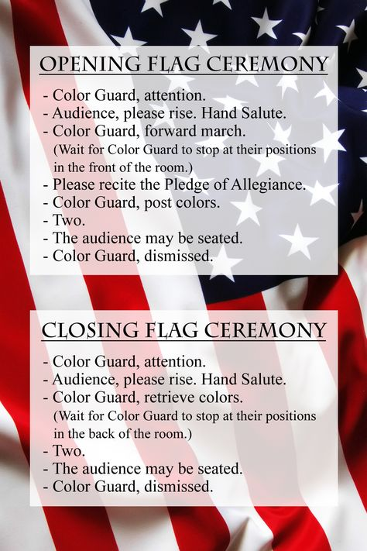
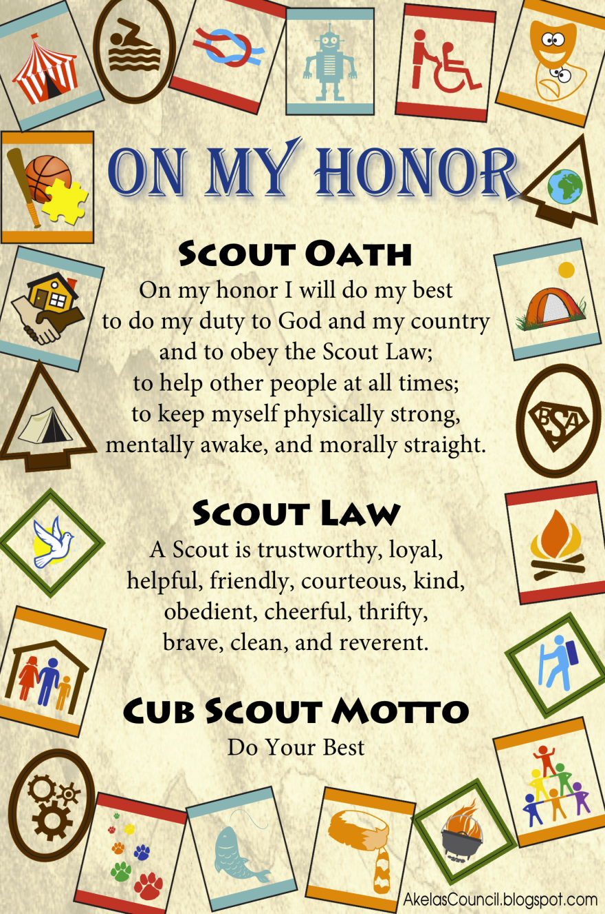
"Color Guard, Attention!"
"Audience, Please Rise!"
"Scout Salute! Those not in uniform, please place your right hand over your heart."
"Color Guard, Forward March!" (Wait for color guard to reach the stands.)
"Color Guard, Post the Flag of the United States of America!"
"Color Guard, Post the Pack 183 Flag!”
"Please recite the Pledge of Allegiance!"
"TWO!" (Everyone drops salute )
"Scout Sign!" (Everyone raises right hand making the Scout sign)
"Please join us in reciting the Scout Oath and Scout Law!"
"TWO!" (Everyone drops Scout sign)
"Audience, Please be seated!"
"Color Guard, Dismissed!"
Opening Prayer Examples
The Cub Scout Prayer
Help us, dear God, to love thee day by day;
To do our duty to you and enjoy our play;
To keep our cub scout promise the best that
we can; And to do our best always to help
our fellow man.
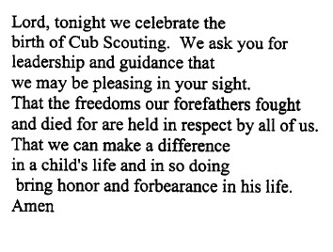
Amen

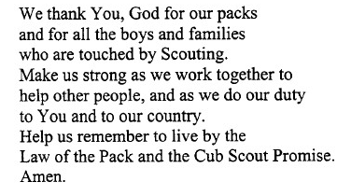
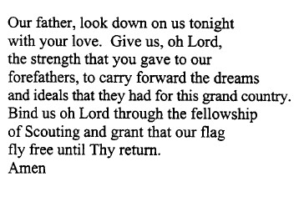
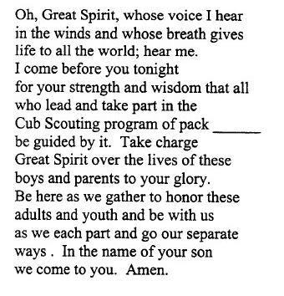
Assignment  Sheet |  | Set-up | Flags | Prayer | Clean-up
Pack Meeting | August | Arrow Of Light | Web I | Bears | Wolves/Tigers
Pack Meeting | September | Wolves/Tigers | Arrow Of Light | Web I | Bears
Pack Meeting - Campfire Program | October | Bears | Wolves/Tigers | Arrow Of Light | Web I
Pack Meeting | November | Web I | Bears | Wolves/Tigers | Arrow Of Light
Pack Meeting | January | Arrow Of Light | Web I | Bears | Wolves/Tigers
Blue & Gold Program | February | Arrow Of Light | Arrow Of Light | Arrow Of Light | Arrow Of Light
Pack Meeting - Campfire Program | March | Web I | Bears | Wolves/Tigers | Web I
Pack Meeting - Rank Up | April | Wolves/Tigers | Web I | Bears | Wolves/Tigers
Pack Meeting - Crossover | May | Bears | Wolves/Tigers | Web I | Bears

